# **COMP9415-Computer Graphics**

**Project Proposal**

# **Term 3, 2022**

**Team members:**

AMAL RAMADAN ALSHAMMARI (z5275908)

Leung Hoi Kit (z5339466)

Wang Liao (z5306313)

XIANGYANG XU (z5387048)

**Lecturer:**

Ali Darejeh.

**Contents:**

1. Existing systems 3
2. The purpose of the system 5
3. Different features of the system 6
4. Technical depth and novelty of the system 7
5. System flow 8
6. Wireframe / mock-up of your system 9

**SECTION 1: (Existing Systems)**

|  |
| --- |
| **RESEDINT EVIL 7 (system 1)** |

|  |
| --- |
| **ADVANTAGES:** |
| 1)  Interactive system  The RE7 interaction system is very interesting. Players often need to interact with some items in the scene to unlock next scene or solve puzzles. At the same time, there are a lot of interaction elements in the fight. In the fight with the boss, you need to interact with its weaknesses when it enters a weak state to cause damage. These have brought better experience and immersion to players. |
| 2)  Puzzle solving system  In my opinion, this is the most attractive part of biochemical crisis. A horror game is difficult to attract most players if it is only scary. It can only be done when it is interesting enough. RE7 makes this game very interesting through its interesting and exciting puzzle solving system. You may need to find the answer under the pursuit of the enemy or get hints or tools through numerous dangers to solve the final puzzle. |
| **DISADVANTAGES:** |
| 1)  Some of the users are facing slowness and poor when they run the game, and they mentioned that sometimes it just suddenly begins to stutter, and another issue that the players were facing is that the game is facing some poorness in depth in some places or levels. |
| 2)  The scene in the first person is too narrow Because the game background of RE7 takes place in a small wooden house, the game spends most of its time exploring in this dark and narrow wooden house, which leads to a very narrow vision of players in the first person, and slight shaking can cause dizziness. After reading the recent negative comments of steam, many players rejected RE7 because of this reason. |

|  |
| --- |
| **VALORANT (system 2)** |
| **ADVANTAGES:** |
| 1)  Economy system & Weapon System  Players can access the buy menu after each round, and the money the player has earned from the previous round will be transferred to the next round. In the buy menu, there are different categories of weapons: sidearms, SMGs, shotguns, rifles, snipers, and machine gun, etc. The rich weapon system provides players with a variety of options. They can choose unique combat methods according to the scene or preference. The weapon system is balanced as no gun is overpowering. With the economy system, players need to have enough money to buy specific weapons, this is conducive to the balance of game and diversity of the game. |
| 2)  Ultimate Ability  Each character in Valorant has their own ultimate abilities that can be used to significant advantage in different combat scenarios. Unique skills highlight the character's characteristics and make the entire combat system more interesting. This flashy design also makes Valorant different from traditional FPS such as CSGO. |
| **DISADVANTAGES:** |
| 1)  Control System  Player moves too slow, and the attack damage of bullet is too high. When player get out of cover, they gets kill easily. The pathway of the bullet is random. New players need to use a long period of time to understand the principle. It is too hard to aim and do some advance technique. |
| 2)  Map Design  Map is too small, and road are not wide enough. Some of the guns and characters are useless due to this reason. For example, it is good to have several guns choice in Valorant. However, some of the gun will not be consider using in different e-sport team because of the map design. This limits the diversity of the game. |

**SEC 2**

**Purpose of the system (0.5 page)**

* **explain what the system will do:**
  + It is a FPS game summarized on a player facing zombies “with different characters and power levels”, trying to survive. The game contains a different type of weapon such as: guns and knives. It will be played in a horror environment with some sound effects to give the sense of reality.
  + It gives fun to players, and develops play skills).
  + You can make profit (if you decide to publish it in stream, or stream playing it).
* **explain the target users:**
  + PC and Console gamer, FPS fans and age limit +14
* **how it can solve any problems the existing systems(RE7):**
  + **In 4 main sections:**
    - Scene: increase the reality in the scene and make it clearer to see.
    - Performance: Make the player respond faster to the commands.
    - Control system: Make the player easier to control with mouse or keyboard.
    - Map design: Will be wider than RE7 design to give ample visibility.
* **how it can solve any problems the existing systems(VALORANT):**
  + **in 5 main sections:**
    - Player movement: Adjust the player's movement speed to a moderate level without affecting the player's gaming experience.
    - Weapon attack damage:Taking into account the target's HP, the player's HP, and the increase in later game difficulty, etc., the weapon damage is adjusted to moderate.
    - Bullet path: More stable bullet trajectory.
    - Difficulty: There is a game difficulty that allows novice players to quickly adapt to the game (it is best to divide the game difficulty into levels for players to choose).
    - Map: Large enough to allow players to explore without feeling limited.

**SEC 3**

**Features of our system (0.5-1 page)**

|  |  |  |
| --- | --- | --- |
| Type of feature | Feature name | Description |
| Non-technical | Character | A variety of game characters are available for players to choose. Game characters have health, energy, armor, can use weapons, and can use ultimate abilities to attack zombies by consuming energy. |
| Non-technical | Ability | Ultimate abilities of game characters, such as AOE to clear zombies in a large area, restoring HP and energy, flying, increasing movement speed, and increasing weapon damage, etc. |
| Non-technical | Weapon | The weapon system is designed in the form of guns and melee weapons, which can have different types and appearances. |
| Non-technical | Zombies | Zombies are the most basic monsters in the game, with health and attack power, as well as clumsy mobility. |
| Non-technical | Boss | As a high-level enemy, the boss has high health bar, attack damage, faster movement speed, and huge size. |
| Non-technical | Map | The map should be large enough for players to fully explore, with uneven terrain, jumping platforms, etc. [We can also consider designing scene elements such as doors and cages] |
| Non-technical | Goals | After the player has achieved the corresponding goal, it is regarded as the game victory, such as killing the boss, surviving within the specified time, etc. |
| Technical | Implementation of stable bullet trajectory | [adjust the backend algorithms of the bullet trajectory as well as keep testing it in the real game] |
| Technical | Implementation of player’s ultimate such as AOE to clean large range of zombies | [The player character gets a projectile that can detonate a large area, or a simpler implementation - fires a super bullet that increases the bullet's damage and size] |

**SEC 4**

**Technical Depth and Novelty of your system:**

Both of the two systems that are similar to the one we follow have a limited movement of the opponent. E.g: the enemies are moving slowly and sometimes crawling which is the reality that is used in most of the games with the system of players VS zombies. In the system that we are going to design there will be more possibility and flexibility in the movement of the enemy to give a greater challenge to the player and test and develop aiming abilities. To achieve this, we will add some additional action feature to the zombies (they are the enemies), so when the player is faced with these enemies, it will be more difficult to target and kill these zombies than the last two systems.

**How the feature will be applied to the new system:**

* Give the ability for the zombies to jump from one place to another (to give the player some distraction and challenging while aiming and shotting).

- Give the ability to move fluently and flexibly for both player and enemies.

**Sec 5 : System flow**

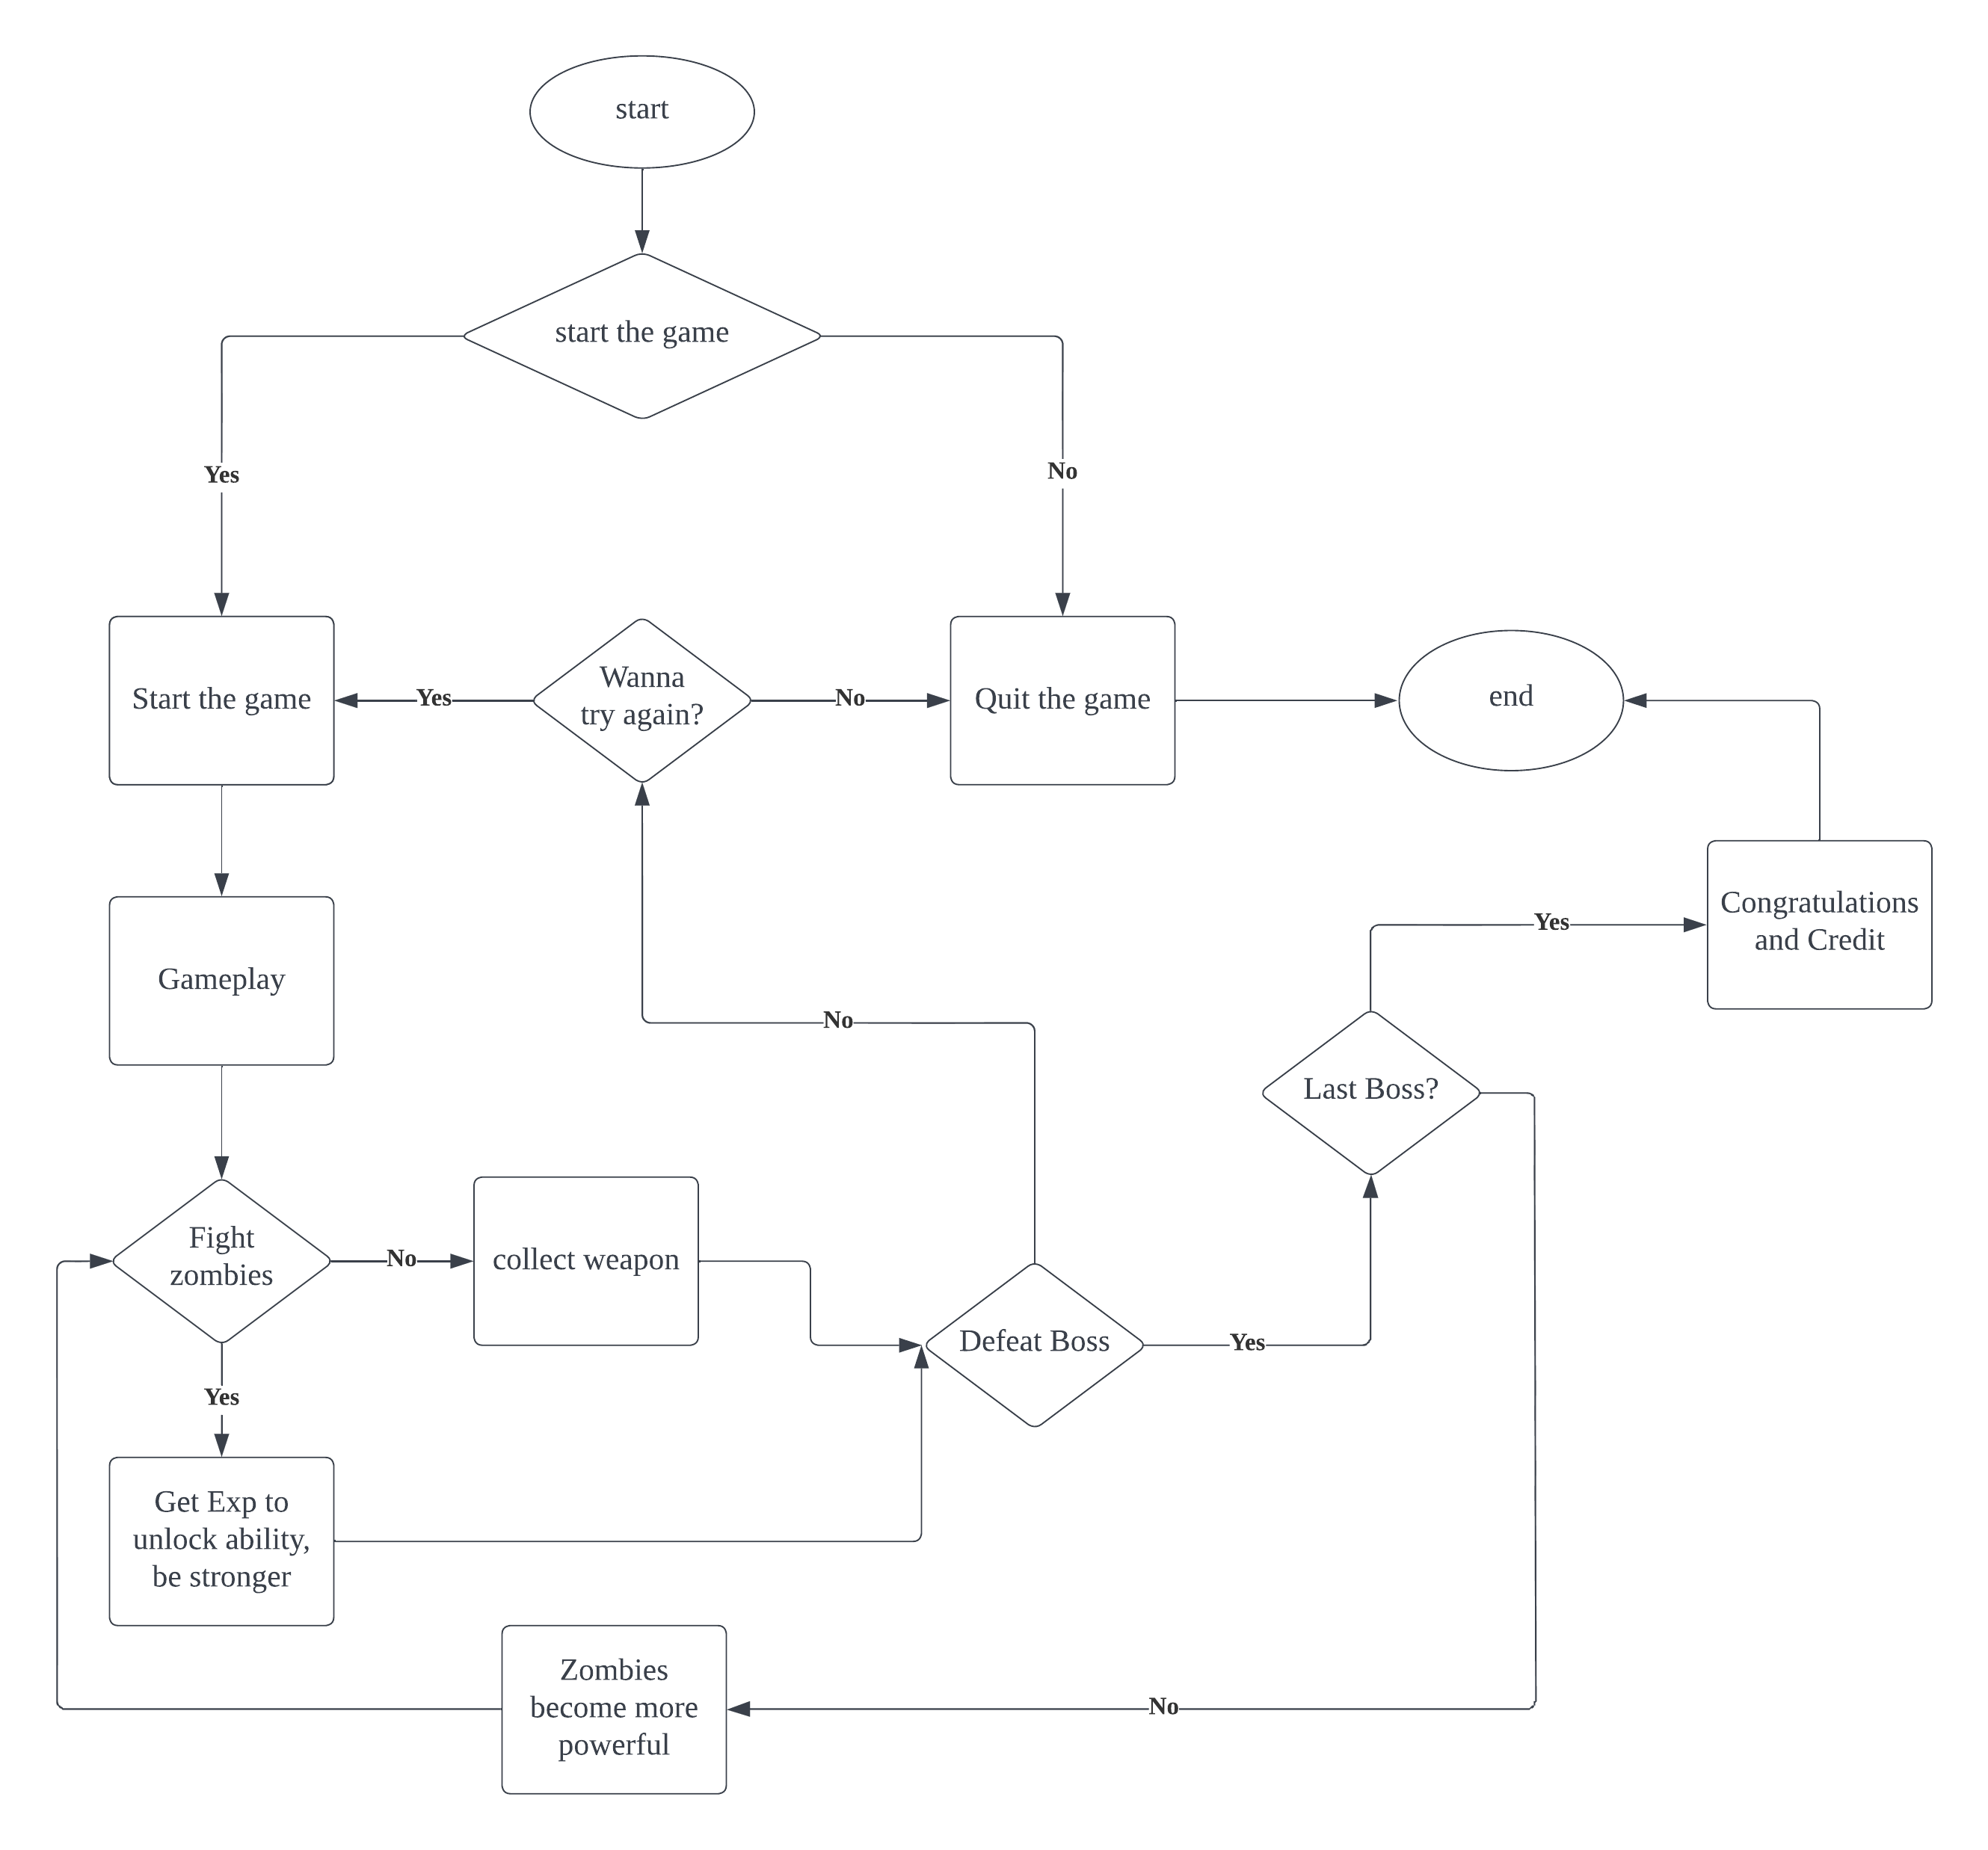

**SEC 6**

**Wireframe / mock-up of the system**

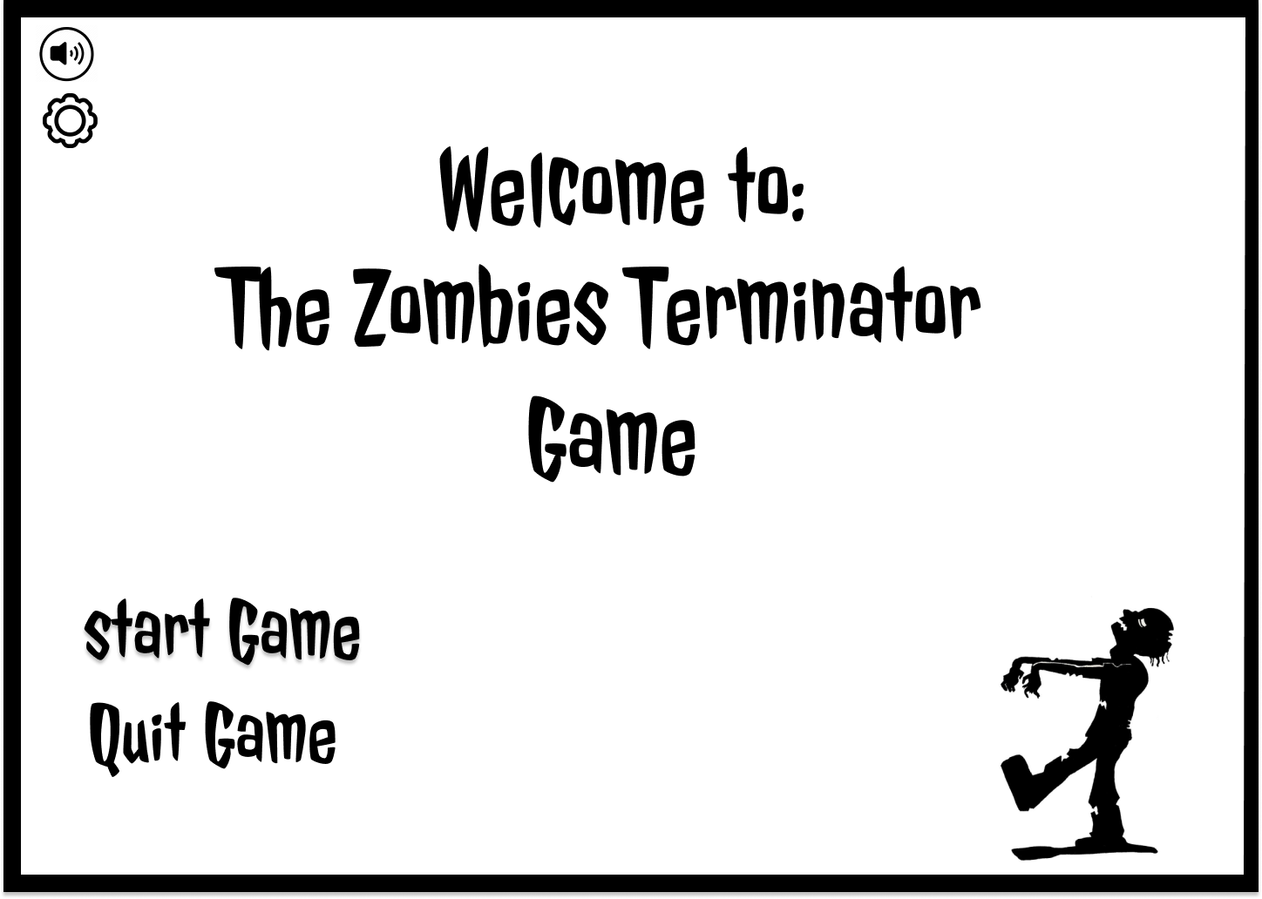**The beginning page:**

**The player page:**

**The Zombies page:**

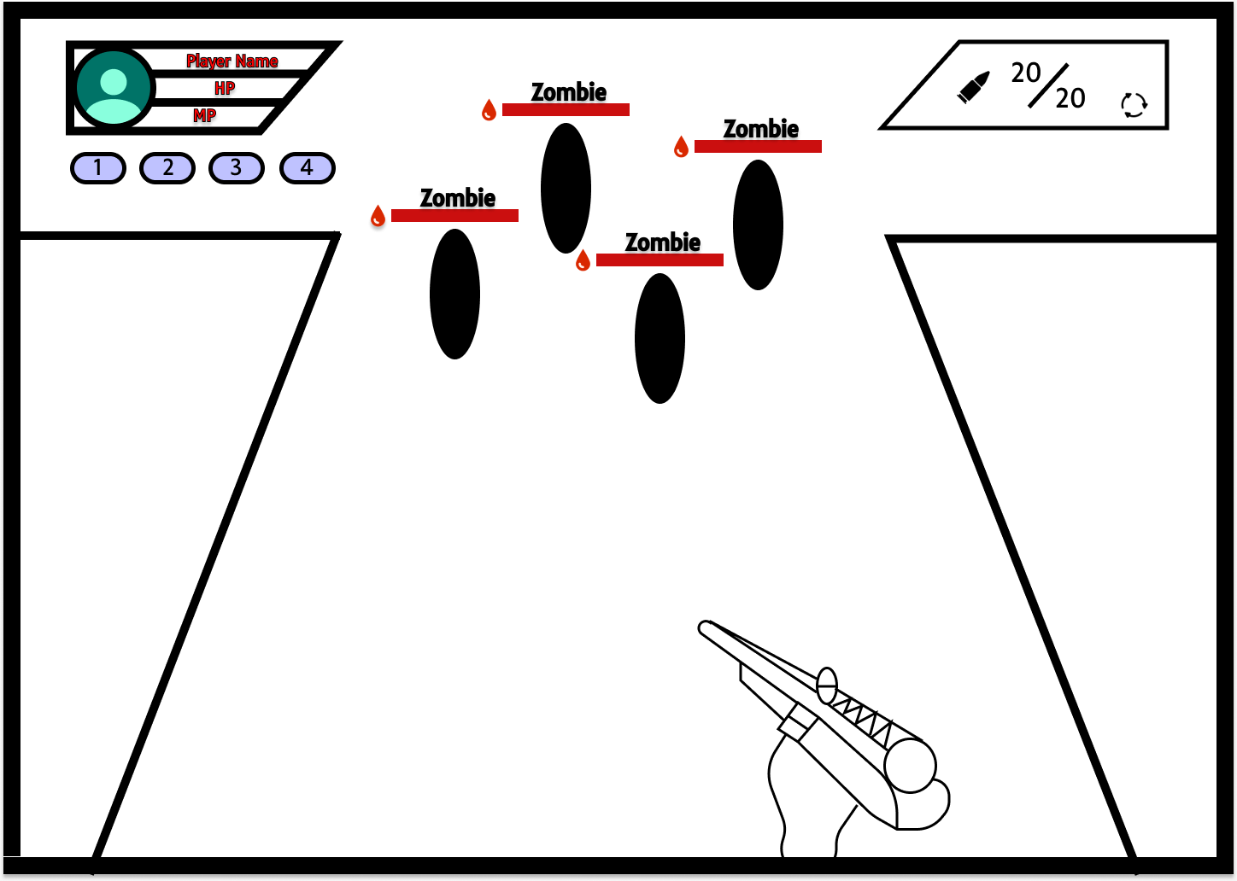

**The Boss page:**

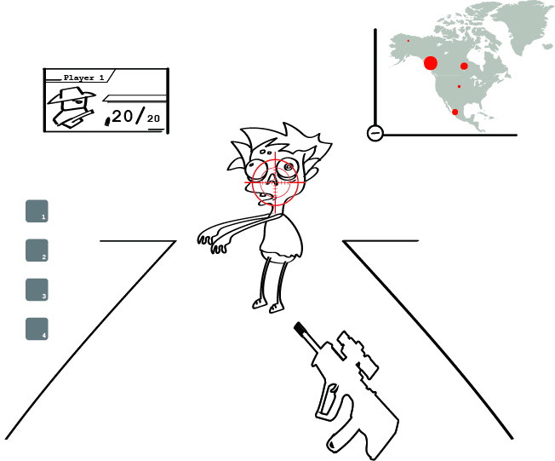

**The end pages (winning/Losing):**

**Winning:**

